ASSIGNMENT 6-dsa
DIVANSHI GARG(1024030441)

Ques1)
#include <iostream>
using namespace std;

class DLL {
private:
struct Node {
int data;
Node* prev;
Node* next;
} *head;

public:
DLL() {
head = NULL;
}

void insertAtBegin(int val) {
Node* newNode = new Node{val, NULL, head};
if (head != NULL)
head->prev = newNode;
head = newNode;
}

void insertAtEnd(int val) {
Node* newNode = new Node{val, NULL, NULL};
if (head == NULL) head = newNode;
else {
Node* temp = head;
while (temp->next != NULL) temp = temp->next;
temp->next = newNode;
newNode->prev = temp;
}
}

void insertAfter(int key, int val) {
Node* temp = head;
while (temp != NULL && temp->data != key) temp = temp->next;
if (!temp) { cout << "Node not found!\n"; return; }
Node* newNode = new Node{val, temp, temp->next};
if (temp->next != NULL) temp->next->prev = newNode;
temp->next = newNode;
}

void deleteNode(int key) {
Node* temp = head;
while (temp != NULL && temp->data != key) temp = temp->next;
if (!temp) { cout << "Node not found!\n"; return; }

if (temp->prev) temp->prev->next = temp->next;
else head = temp->next;

if (temp->next) temp->next->prev = temp->prev;
delete temp;
cout << "Node deleted!\n";
}

bool search(int key) {
Node* temp = head;
while (temp != NULL) {
if (temp->data == key) return true;
temp = temp->next;
}
return false;
}

void display() {
Node* temp = head;
while (temp != NULL) {
cout << temp->data << " <-> ";
temp = temp->next;
}
cout << "NULL\n";
}
};

class CLL {
private:
struct Node {
int data;
Node* next;
} *last;
public:
CLL() {
last = NULL;
}

void insertAtBegin(int val) {
Node* newNode = new Node{val, NULL};
if (last == NULL) {
newNode->next = newNode;
last = newNode;
} else {
newNode->next = last->next;
last->next = newNode;
}
}

void insertAtEnd(int val) {
Node* newNode = new Node{val, NULL};
if (last == NULL) {
newNode->next = newNode;
last = newNode;
} else {
newNode->next = last->next;
last->next = newNode;
last = newNode;
}
}

void insertAfter(int key, int val) {
if (!last) { cout << "List Empty\n"; return; }
Node* temp = last->next;
do {
if (temp->data == key) {
Node* newNode = new Node{val, temp->next};
temp->next = newNode;
if (temp == last) last = newNode;
return;
}
temp = temp->next;
} while (temp != last->next);
cout << "Node not found!\n";
}

void deleteNode(int key) {
if (!last) { cout << "List Empty\n"; return; }
Node *temp = last->next, *prev = last;

do {
if (temp->data == key) {
if (temp == last && temp->next == last) last = NULL;
else {
prev->next = temp->next;
if (temp == last) last = prev;
}
delete temp;
cout << "Node deleted!\n";
return;
}
prev = temp;
temp = temp->next;
} while (temp != last->next);

cout << "Node not found!\n";
}

bool search(int key) {
if (!last) return false;
Node* temp = last->next;
do {
if (temp->data == key) return true;
temp = temp->next;
} while (temp != last->next);
return false;
}

void display() {
if (!last) { cout << "Empty\n"; return; }
Node* temp = last->next;
do {
cout << temp->data << " -> ";
temp = temp->next;
} while (temp != last->next);
cout << "(Back to Head)\n";
}
};

int main() {
DLL dll;
CLL cll;
int choice, listChoice;

do {
cout << "\n1. Doubly Linked List\n2. Circular Linked List\n3. Exit\nEnter choice: ";
cin >> listChoice;

if (listChoice == 3) break;

int ch, val, key;
do {
cout << "\n1.Insert at Begin\n2.Insert at End\n3.Insert After\n"
<< "4.Delete Node\n5.Search Node\n6.Display\n7.Go Back\nEnter: ";
cin >> ch;

switch(ch) {
case 1: cout << "Enter value: "; cin >> val;
(listChoice == 1 ? dll.insertAtBegin(val) : cll.insertAtBegin(val)); break;
case 2: cout << "Enter value: "; cin >> val;
(listChoice == 1 ? dll.insertAtEnd(val) : cll.insertAtEnd(val)); break;
case 3: cout << "Enter key: "; cin >> key;
cout << "Enter value: "; cin >> val;
(listChoice == 1 ? dll.insertAfter(key,val) : cll.insertAfter(key,val)); break;
case 4: cout << "Enter value to delete: "; cin >> key;
(listChoice == 1 ? dll.deleteNode(key) : cll.deleteNode(key)); break;
case 5: cout << "Enter value to search: "; cin >> key;
cout << ((listChoice == 1 ? dll.search(key) : cll.search(key)) ? "Found!" : "Not Found!") << endl;
break;
case 6: (listChoice == 1 ? dll.display() : cll.display()); break;
}
} while (ch != 7);
} while(true);
return 0;
}
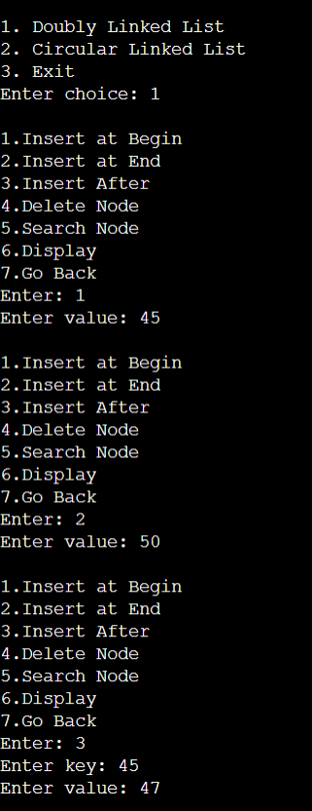
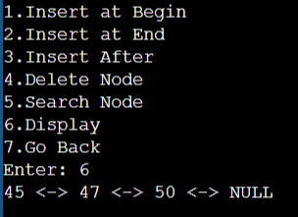

Ques2)
#include<iostream>
using namespace std;

class CLL {
private:
struct Node {
int data;
Node* next;
} *last;

public:
CLL() {
last = NULL;
}

void insertNode(int val) {
Node* newNode = new Node{val, NULL};
if (last == NULL) {
newNode->next = newNode;
last = newNode;
} else {
newNode->next = last->next;
last->next = newNode;
last = newNode;
}
}

void display() {
if (!last) { cout << "Empty\n"; return; }
Node* temp = last->next;
do {
cout << temp->data << " -> ";
temp = temp->next;
} while (temp != last->next);
cout << temp->data;
}
};

int main(){
CLL cll;
cll.insertNode(20);
cll.insertNode(100);
cll.insertNode(40);
cll.insertNode(80);
cll.insertNode(60);

cll.display();
return 0;
}

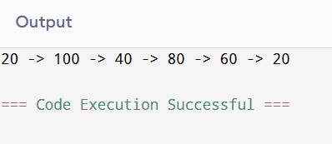

Ques3)
#include<iostream>
using namespace std;

class CLL {
private:
struct Node {
int data;
Node* next;
} *last;

public:
CLL() {
last = NULL;
}

void insertNode(int val) {
Node* newNode = new Node{val, NULL};
if (last == NULL) {
newNode->next = newNode;
last = newNode;
} else {
newNode->next = last->next;
last->next = newNode;
last = newNode;
}
}

void display() {
if (!last) {
cout << "Empty\n";
return;
}
Node* temp = last->next;
do {
cout << temp->data << " -> ";
temp = temp->next;
} while (temp != last->next);
cout << "(back to head)\n";
}

int sizeCLL() {
if (!last) return 0;

int count = 0;
Node* temp = last->next;

do {
count++;
temp = temp->next;
} while (temp != last->next);

return count;
}
};

class DLL {
private:
struct Node {
int data;
Node* prev;
Node* next;
} *head;

public:
DLL() {
head = NULL;
}

void insertAtEnd(int val) {
Node* newNode = new Node{val, NULL, NULL};
if (head == NULL) head = newNode;
else {
Node* temp = head;
while (temp->next != NULL)
temp = temp->next;
temp->next = newNode;
newNode->prev = temp;
}
}

void display() {
Node* temp = head;
while (temp != NULL) {
cout << temp->data << " <-> ";
temp = temp->next;
}
cout << "NULL\n";
}

int sizeDLL() {
int count = 0;
Node* temp = head;
while(temp != NULL) {
count++;
temp = temp->next;
}
return count;
}
};

int main() {
CLL cll;
DLL dll;

cll.insertNode(1);
cll.insertNode(2);
cll.insertNode(3);

cll.display();
cout << "Size of Circular Linked List: " << cll.sizeCLL() << endl;

dll.insertAtEnd(10);
dll.insertAtEnd(20);
dll.insertAtEnd(30);

dll.display();
cout << "Size of Doubly Linked List: " << dll.sizeDLL() << endl;

return 0;
}
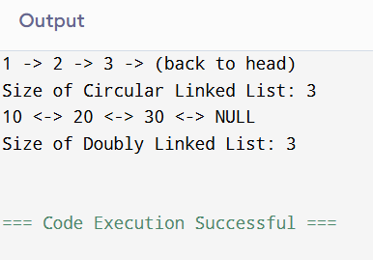

Ques4)
#include <iostream>
using namespace std;

class DLL {
private:
struct Node {
char data;
Node* prev;
Node* next;
};

Node* head;
Node* tail;

public:
DLL() {
head = NULL;
tail = NULL;
}

void insertAtEnd(char ch) {
Node* newNode = new Node{ch, NULL, NULL};
if (!head) {
head = tail = newNode;
} else {
tail->next = newNode;
newNode->prev = tail;
tail = newNode;
}
}

bool isPalindrome() {
if (!head) return true; // empty list is palindrome

Node* left = head;
Node* right = tail;

while (left != right && right->next != left) {
if (left->data != right->data)
return false;
left = left->next;
right = right->prev;
}
return true;
}

void display() {
Node* temp = head;
while (temp != NULL) {
cout << temp->data << " <-> ";
temp = temp->next;
}
cout << "NULL\n";
}
};

int main() {
DLL dll;

dll.insertAtEnd('m');
dll.insertAtEnd('a');
dll.insertAtEnd('d');
dll.insertAtEnd('a');
dll.insertAtEnd('m');

dll.display();

if (dll.isPalindrome())
cout << "The Doubly Linked List is a PALINDROME.\n";
else
cout << "The Doubly Linked List is NOT a palindrome.\n";

return 0;
}
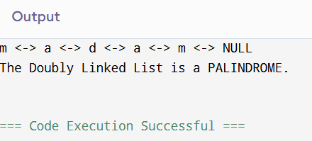
Ques 5)
#include<iostream>
using namespace std;

class CLL {
private:
struct Node {
int data;
Node* next;
} *last;

public:
CLL() {
last = NULL;
}

void insertNode(int val) {
Node* newNode = new Node{val, NULL};
if (last == NULL) {
newNode->next = newNode;
last = newNode;
} else {
newNode->next = last->next;
last->next = newNode;
last = newNode;
}
}

bool isCircular() {
if (last == NULL)
return false;

Node* temp = last->next;
while (temp != NULL) {
temp = temp->next;

if (temp == last->next)
return true;
}
return false; // If NULL found
}
void display() {
if (!last) { cout << "Empty\n"; return; }
Node* temp = last->next;
do {
cout << temp->data << " -> ";
temp = temp->next;
} while (temp != last->next);
cout << temp->data;
cout<<endl;
}
};

int main(){
CLL cll;
cll.insertNode(2);
cll.insertNode(4);
cll.insertNode(6);
cll.insertNode(7);
cll.insertNode(5);

cll.display();

if(cll.isCircular()){
cout<<"linked list is circular!"<<endl;
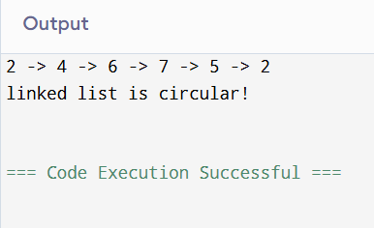
}else
cout<<"linked list NOT circular.";
return 0;
}

